**1st Manual Test Task:**

***007museum.com issues:***

Environment and preconditions:

* OS: Windows 11
* Browser: Google Chrome - Version 126.0.6478.185 (Official Build) (64-bit)
* Navigate to: <http://www.007museum.com/>

1. **First ‘index.html’ page leads to the same page with long loading:**

Severity: **Low**

Test steps:

1. Click on first huge image (displayed over entire page) displayed

Expected result:

1. Expecting to navigate to another page or to change page for viewing, or to refresh page

Actual result:

1. Browser open new same page but on other tab.

Tester’s observation comment:

It makes no sense to open the same page in new tab. This might not be defect but it can confuse customer

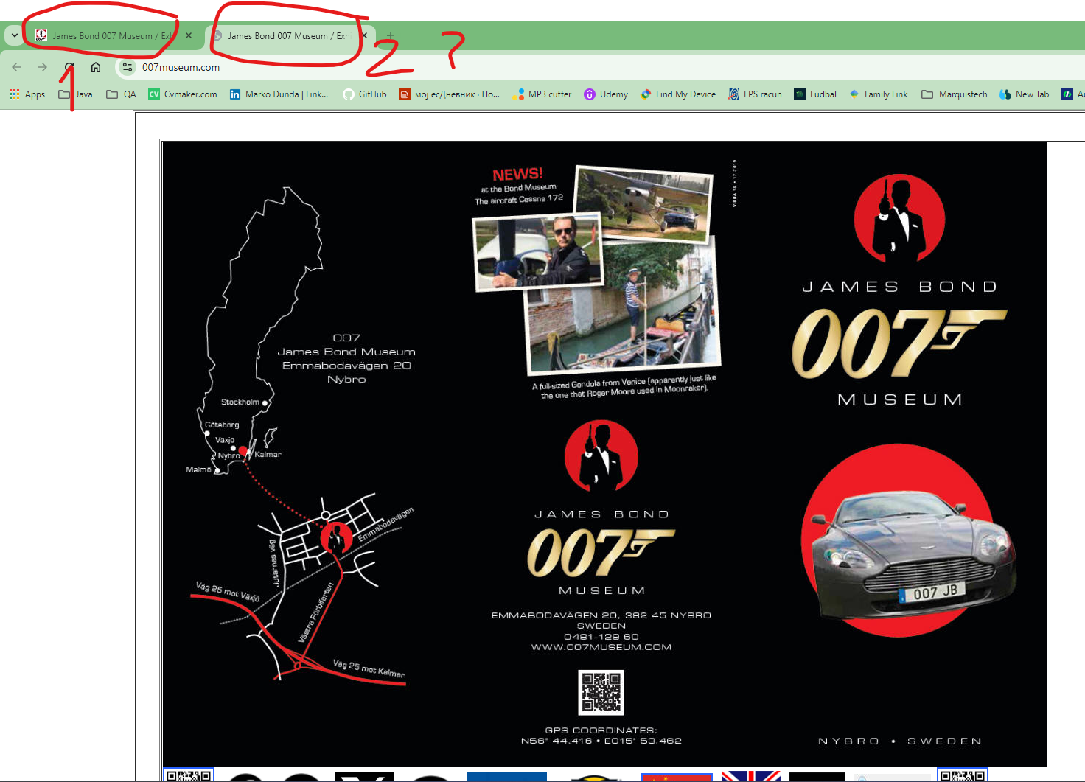 

1. **E-mail is written in another (Serbian) language:**

Severity: **Low**

Test steps:

1. Scroll little bit down under home page

Expected result:

1. It should be written: e-mail, or email

Actual result:

1. mejl is written (it is in Serbian or similar language, not in English)

Tester’s observation comment:

Customer would understand this, but it is not professional to be left like this

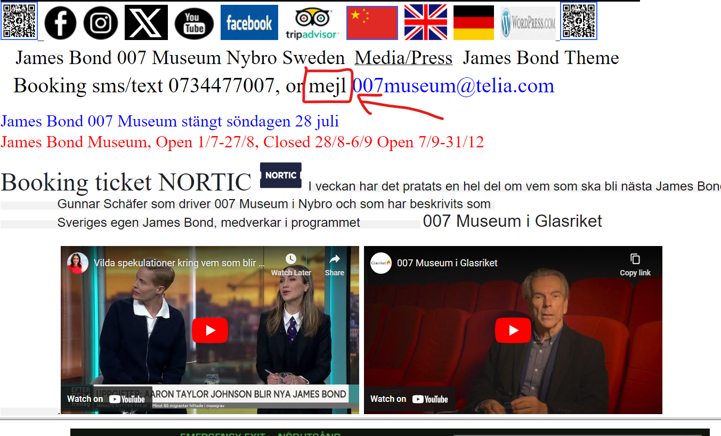

1. **Unnecessary text is clickable or hyperlinked :**

Severity: **Low**

Test steps:

1. Scroll down under home page and flags
2. Click on text right from bold ‘Booking ticket’

Expected result:

1. It should direct to somewhere else, or it shouldn’t be clickable

Actual result:

1. It opens same page in new tab. 1st defect is repeated

Tester’s observation comment:

‘Booking ticket’ should be clickable only

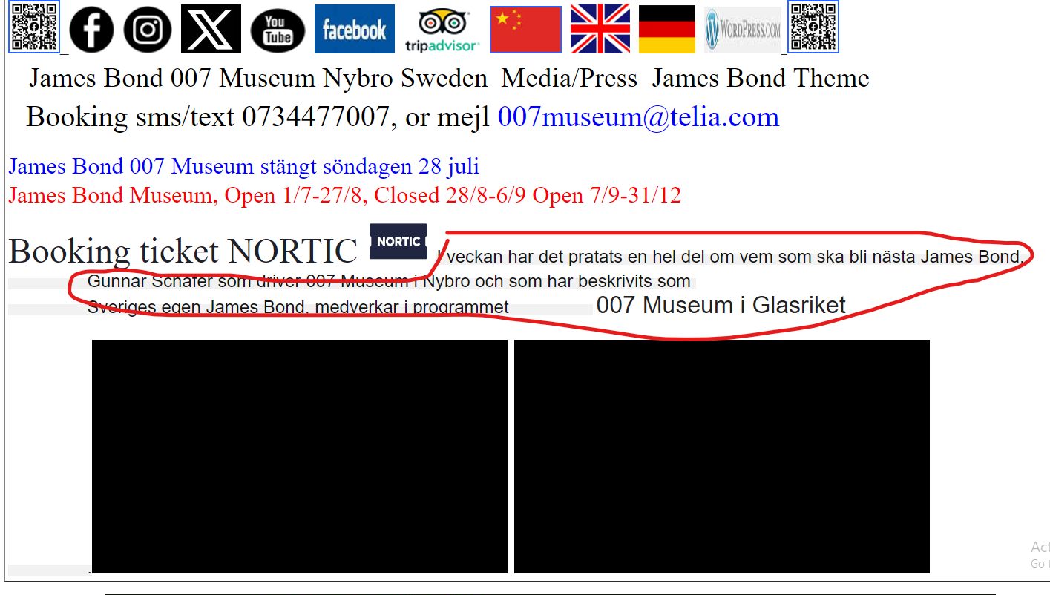



1. **Unexpectedly downloading sound file:**

Severity: **Medium**

Test steps:

1. Scroll down below home picture page
2. Click on first text under the flags
3. In the new opened page, click on first text under picture.

Expected result:

2) Redirected to new page on new tab

1. It should redirect to somewhere else, maybe to booking page

Actual result:

1. Some unknown sound file got downloaded!

Tester’s observation comment:

Customer/subscriber can consider this unknown music file as virus so there is real concern here!

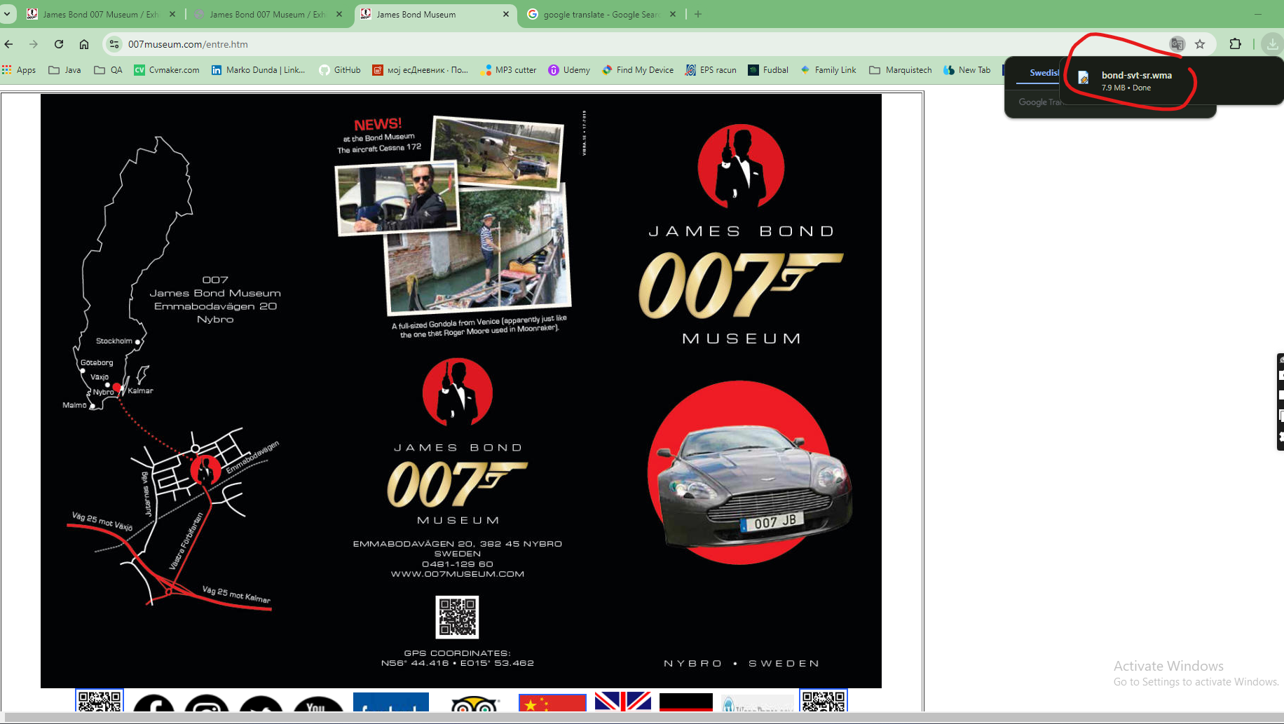



1. **Broken picture to redirect:**

Priority: **Low**

Test steps:

1. Scroll down to ‘The Other Fellow’ image
2. Click on it

Expected result:

2) It should direct to proper movie or trailer

Actual result:

2) 404 error page shown.

Tester’s observation comment:

Movie is probably removed from redirected page.

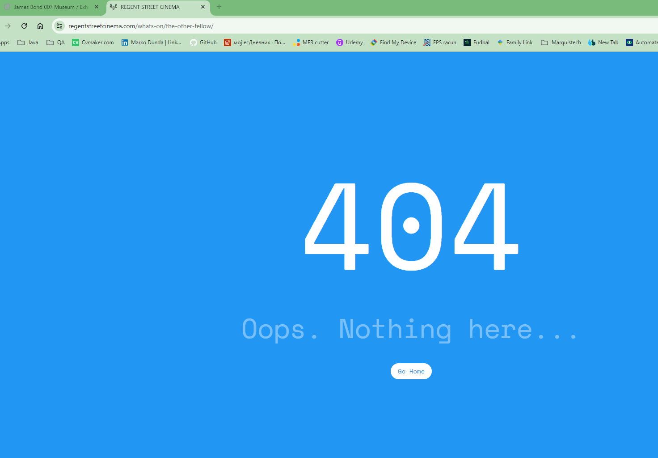 

1. **Broken text to redirect:**

Priority: **Low**

Test steps:

1. Scroll down to ‘Omega Seamaster section 300’
2. Click on text right or under it

Expected result:

4) It should direct to proper page

Actual result:

4) 404 error page shown.

Tester’s observation comment:

Page is probably removed from redirected page.

